Final Project: Capstone Part 1-5 for Microsoft Full Stack developer with Copilot

Project Summary (what my app does)
The Skill Snap allows users to see their portfolio page, view and add to their list of projects and skills.

Anonymous user
If the page is loaded or being used as anonymous (no user is logged in) they see a sample portfolio page and a link to sign in or register.
If the user click on register, they enter a user name and password and when they save it they are automatically given the role of “staff”.
See picture on next page.
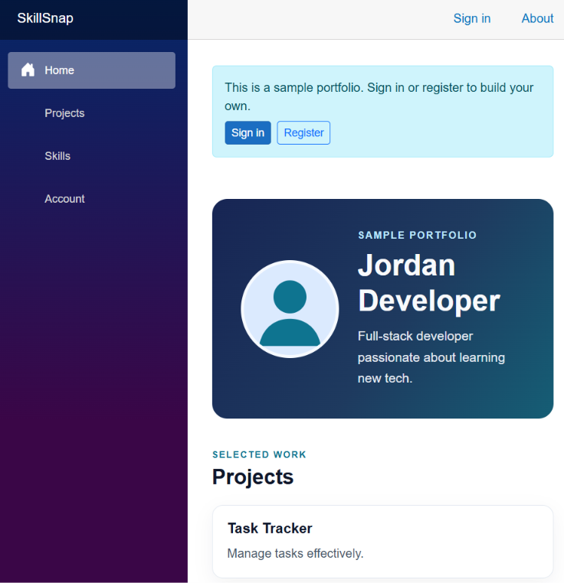
The following page shows what happens when users click on projects or skills.
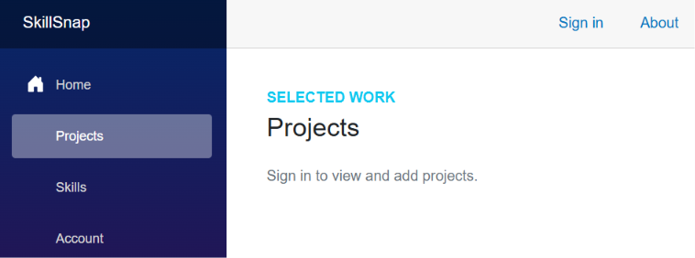

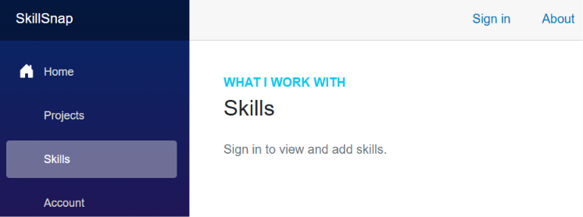

Account
The options under account are Sign in, register, or log out depending on the login state.
As the picture below shows a user by default can enter in their email and password to login. The register link is at the bottom of the page and is called “Create an account”.
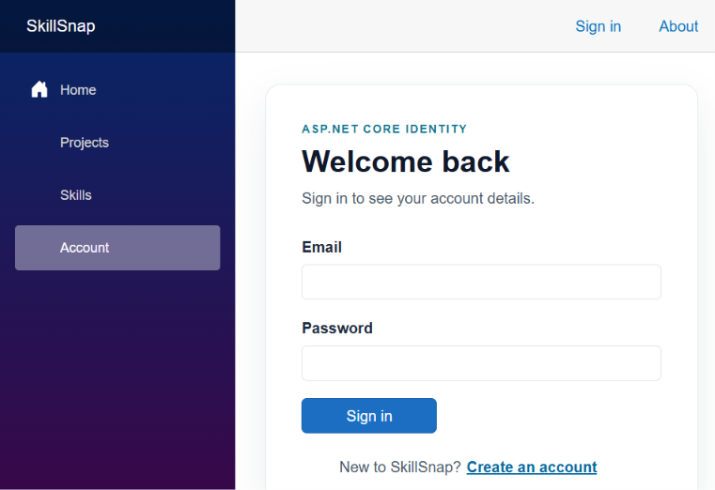

Register account (next page) is the same but the button clearly states you are creating an account. Please note if you try to register with the same email address, you will be told that you are already registered and that you should sign in.
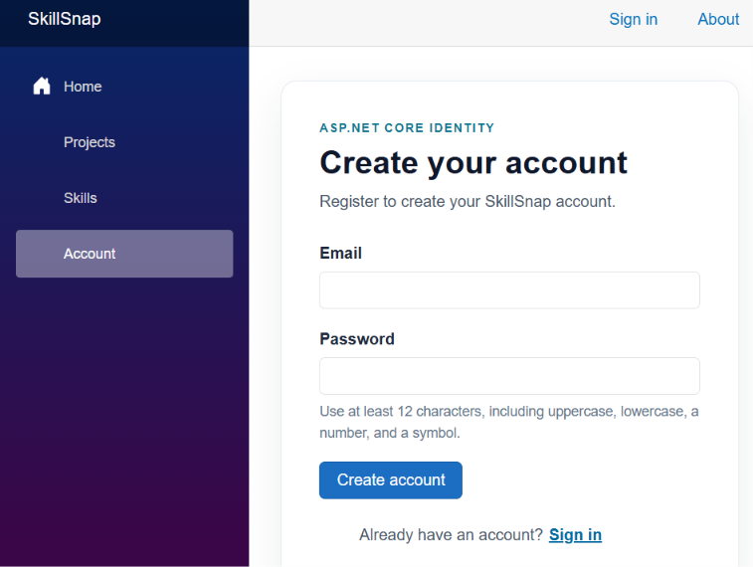

Once logged in, users can see their account details and the Sign out button.
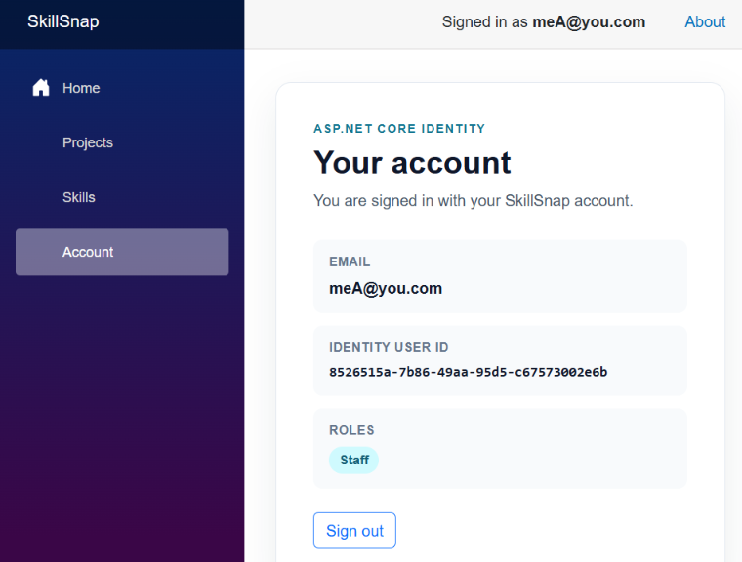

Logged in User
If they click on home, it shows their name, and lists their projects and skills.
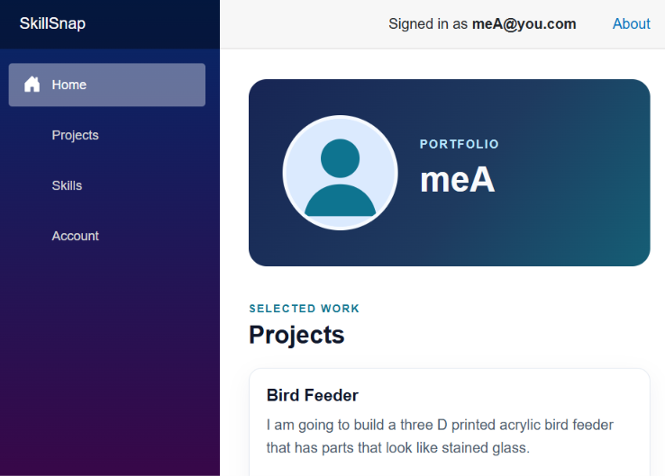
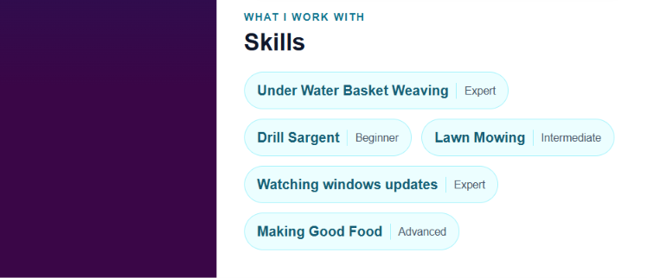
If they click on Projects, they see a list of their projects and have the ability to add a project, or view an existing project. The requirements specify that edits must be done by admins, so that is what I did. The user never gets to see the edit or delete buttons on an individual record unless they are admin.
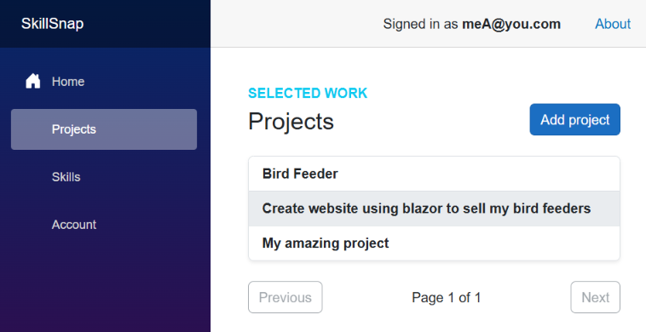
As you can see, the add project button is available, a list of projects with every second record highlighted is visible, and paging is implemented.

When a record is selected, it moves to a view mode where the user can see the hold record with a back button to return to the list.
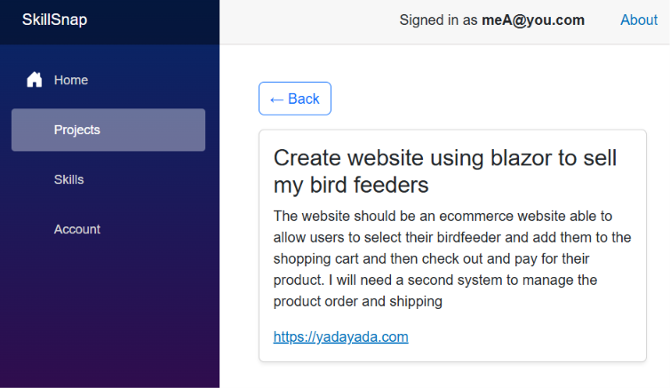

The add project screen allows users to go back to the grid, fill in the fields, and select Save, or close to cancel the add and go back to the previous screen. If the user was part way through entering data and then selects back or Close, the user is asked if they want to cancel and loose the data or not. The following shows the add project screen after the user clicked save with out entering data and shows the error handling messages.
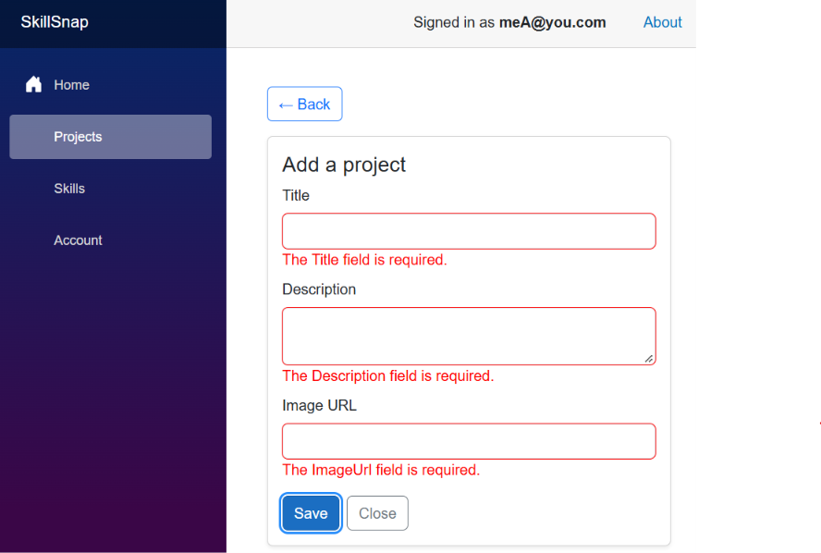

Here is the URL validation:
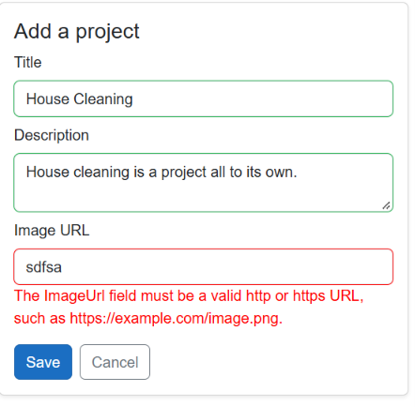

The skills page is much the same
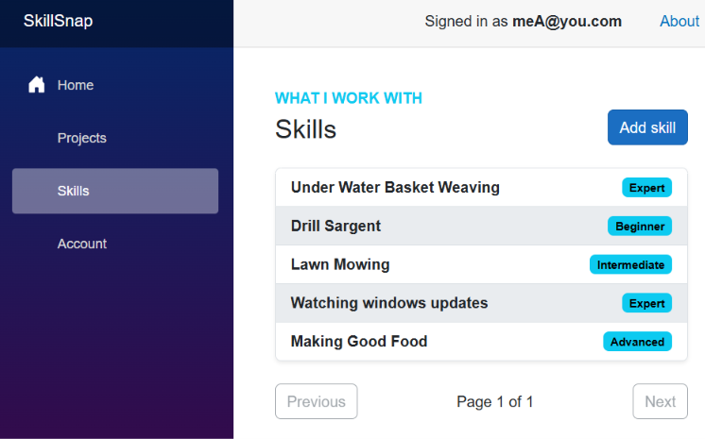

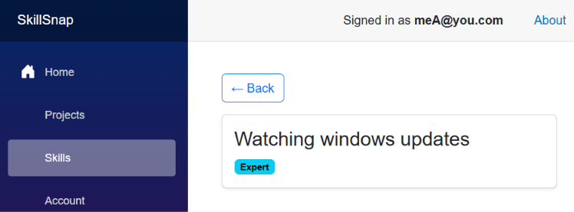

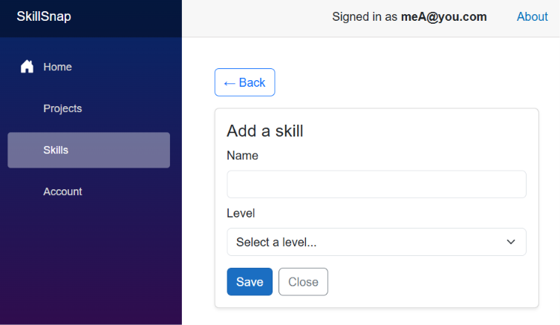

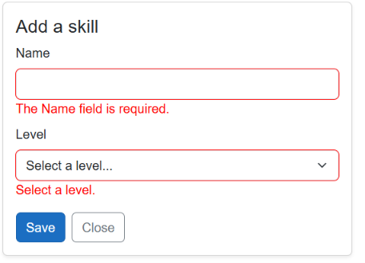

Design change: I made a decision to put Level into a dropdown list so that it was consistent and could be used as a filter and for reports. It also had other learning benefits when we get to caching.
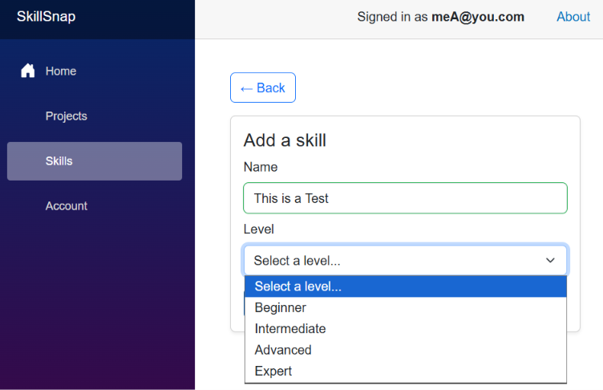

Admin screen variations:
The only difference on the Projects or Skills lists is the toggle button at the top for “Show everyone’s ….” The first screenshots are of just the admins projects and then skills, followed by everyone’s projects or skills.
Note: the Admin is now a blue box in the title bar beside the signed in users name.
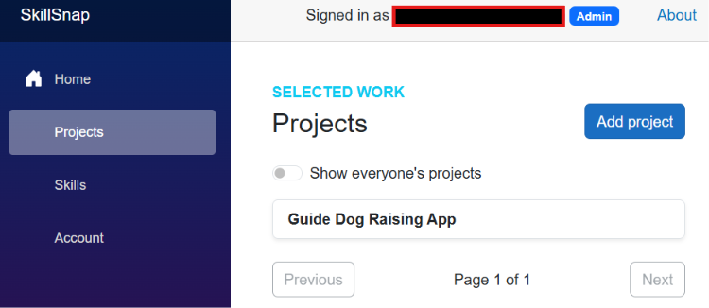

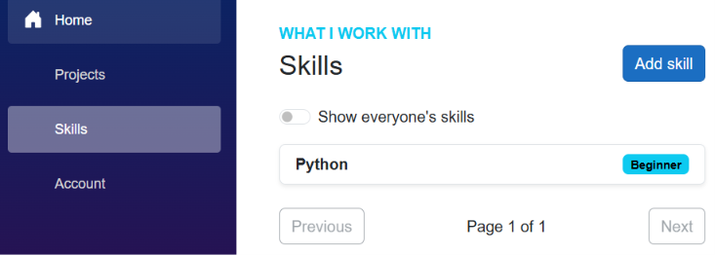

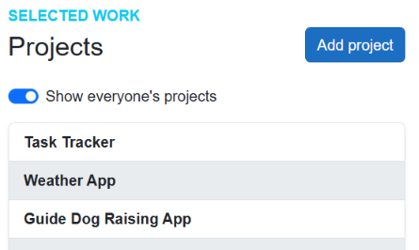
Notice the paging working:
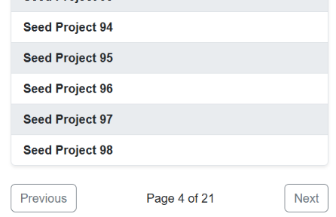

Skills is the same so I won’t show the paging
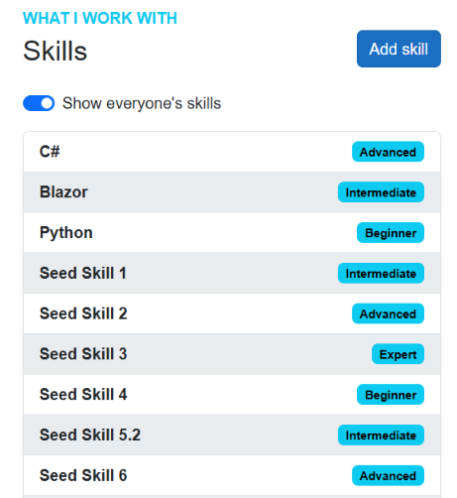

Adding a project or a skill is no different, but if you select a record, you now have the ability to edit or delete the record.

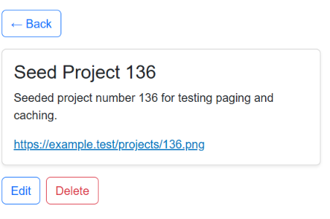

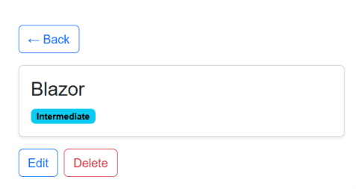

You will notice that the delete gives a warning message, and you will see the admin in the title bar in the background.

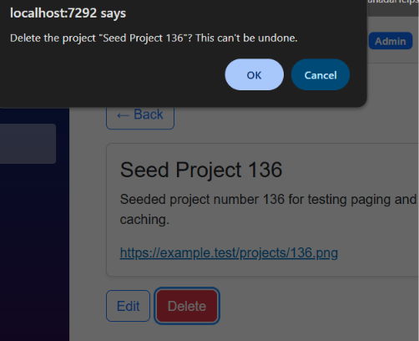

Paging
This paging ensures that it takes only what is needed, and no more. It is a slice of the data with nothing before or after it. This makes the response of the next and previous fast, and it make the website work fast.

Caching
I cached the Skills level and the skill list and the program list. The skill level is valid for 24 hours. The two lists are valid for 1 minute if I remember. The Skill and Project lists are invalidated when a new entry is created.
For the title bar, the users information is cached to list it on the screen every time.

Architecture

Application layout
My architecture is slightly different for a reason. I talked with copilot and here is my summary:
- The old blazorwasm template created a 3 project solution with the model being shared.
- They found that this tighly coupled the blazor app to the api server. So they changed it. The new blazorwasm template is only the blazor front end. The webapi tempalate is only for the backend. The dto services are the contract and using the OpenAPI concept we define the dto’s in the API and the client retrieves the contract from the API using openAPI.
- The DTO’s are just data transfer objects and contain no EF entities, no business logic, and no database code. This keeps the client and the server synchronozed without exposing the server internals.

CORS
So I put them in the same solution and then I used CORS to ensure the front end and back end can talk to each other. I do this through configuration to make the application portable between environments. I enforce HTTPS in CORS and the origins are copilot recommended for the Verbs and header types like Authorization, content-type, x-skillsnap-refresh, and api-version. Github copilot suggested this is the best way to impalement CORS to ensure that only what you want to accept is available to close any gaps.

Data
My database is code first Entity Framework to SQL Server Express. So this folder contains all the migrations. This includes the Identity tables and the model entities that I created that EF picked up and used when creating the database. I note that I created the model with the relationships and inverse relationships so that EF could create the relationships in the database. I did do this with copilots help.
The Dto’s or data transfer objects are a different conversation. It also includes the SkillSnapContext that extends both Identity context and db context and was completely built by Github Copilot. It manages the data from the database, and identity tables like application user, and the refreshtoken.
Skill level I did differently. For me this is always a dropdown box type data set. You don’t want to do text comparisons for each level entry as it is expensive. I had copilot create the SkillLevel lookup table, dto, and SkillLevelCache file to cache the data, which I will talk about shortly. This did result in a SkillLevel Controller, but it was well worth making this change.

Controllers
I used controllers and had Github copilot build them out. They include Authorize when needed, and I use the admin role. They also include the types of response types they will produce.
The project controller is an example of using paging and caching. The Get Projects route expects page, pagesize, the all fag for admins to see all records (not just their own) and the cancelation token to tell the server to stop processing the request. The user information is pulled from cache, and the project get its data from the cache if its available or goes and fetches it from the database using async methods. It does implement .AsNoTraking when it create the var query variable. When a project is created, it invalidates the cache set for Projects.

Security
Security is implemented by using the ASP.NET Identity, implementing Authorize on the appropriate routes in the controllers, and using the users ID in queries so that users can only see their own data unless authorized as Admin to see everyone’s data.
I asked Github Copilot to interact with my SQL Server 2025 express which I installed on my laptop using a code first approach and to do migrations. I asked it to set up the ASP.NET Identity and it also set up all the controllers and updated the application context to use the Identity context as part of the set up.
It also set up the Authorization on the correct routes and, based on the requirements, ensure that edits and deletes were only capable via the Admin.
All users start with the roll of staff for now. That is just a generic users role.
In addition to using the Users ID in the queries to limit them to their own data, I also implemented paging to prevent buffer errors and HTTP response codes. I prompted Copilot to review how error handling is done and it said that the HTTP responses were very generic. I asked it to fix that and it set up HTTP response codes are specific to the condition like record not found, no content, or other types of responses. This improves things.

Development process
I checked with copilot about the blazorwasm template to confirm that it nolonger creates a three project solution with a shared model. For that reason I create a solution and added two projects, one called SkillSnap.Api and another SkillSnap.Client.
In course 10 of this Full Stack certificate, I was asked to create a project like this one. Due to a previous course on Copilot, and some seminars on agentic development, I had learned about the .github/copilot-instructions.md file. I copied that file over from my last project. That told Copilot the database I would use, the set up I wanted, the use of ASP.NET identity, HTTPS, and many other expectations. This file grounds the github copilot and reduces some of the prompting. I also ask it to keep it up to date so that anything new can be added to it for future projects.
I then followed the 5 different steps as requested. I prompted copilot to do the work and it went and did the analysis of the project and did the work. One of the places I did manually was the creation of the model files for PortfolioUser, Project, and Skill. I used copilot to find out how to set that up so that Entity framework would know how to create the database tables with relationships. Once that was done I let Copilot take care of the Dto’s and the controllers. I also prompted copilot to create the blazor components and get the screens working. Then I asked it to refine the design as I made design decisions related to the request by the requirements. This resulted in the screenshots above which I think are reasonably usable by any user.
Authentication was already set up because of my copilot-instructions.md file. So all that copilot needed to add when I asked was the annotations in the controllers and the identity controllers and modes and dtos needed.
Copilot created in my .Api the contracts folder so that Open API can be used by the .Client project to create what it needs.
For the blazorwasm frontend, copilot created the connection to the API and made sure it all worked with CORS. I would regularly test the front end and report anything that was not working correctly. I did need to learn to shut the browser and applications down and restart them to get some of the new features because the wasm was loaded in the browser and needed to download the new wasm code.
Again, following the steps laid out in the course I prompted copilot to do the work incrementally. Copilot created the services for me for the connection to the backend. It also added in the APIExeptions and ApiClientBase classes to create generic code and a way to generically handle exceptions.
The one feature that stand out is the toggle for the admin to see all projects or skills or just their own projects and skills. This toggle was suggested by copilot based on my request to give the admin access to both views. The toggle is a great idea and it implemented all the code associated to it. Most of the challenges related to the front end were related to me not understanding that the front end is loaded into the browser and I need to hard reload it. So it makes it hard to say if copilot got anything wrong when it’s main recommendation is that I restart the browser to get the latest application downloaded to the browser.
At the end I asked Github copilot to create the CI/CD scripts so that the project was ready to deploy to azure.

Remaining issues or Future Improvements
I think this prototype is interesting for a conversation. I think the next round is to do user stories with the people who will be using the application to find out who the people are, how they will use it, what they want to achieve with it and then create a backlog and start working through it.

